MBCI RED CLOSING:
Poles and Mats for both courts neatly placed on the trolly and stored under the stage/office area:
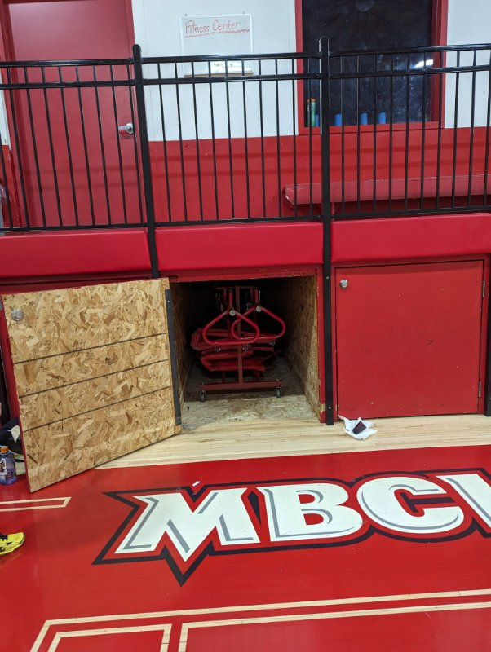

Ref stands for both courts are also stored under the stage/office area:
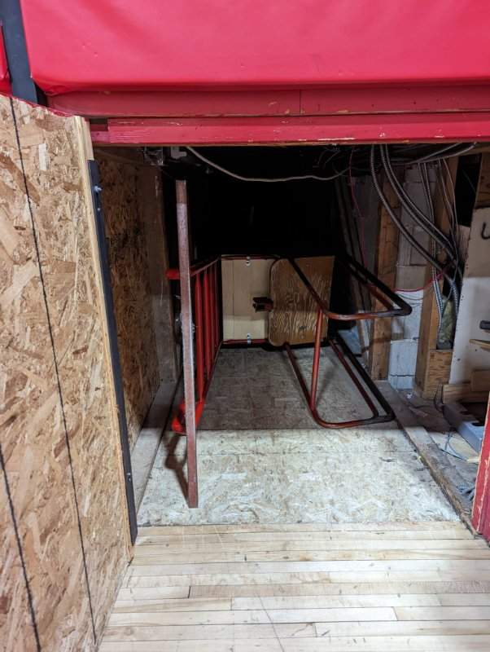

Nets neatly folded and hung on the far end of the gym by court 2.
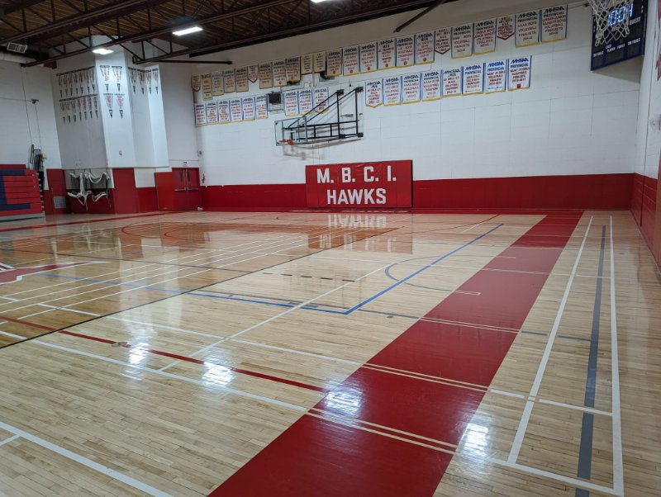
If you're done your game on court 2 but court 1 is still in play, please leave the equipment ready for court 1 to put on the trolley once they are done with their game. Advise the ref/teams on court 1 that poles and ref stand is taken down and ready to be put away after their match.
MAKE SURE GYM IS CLEAN AND GARBAGE THROWN.

